

**VBScript:**

Generic Call a Function Script



# Revision History Page

|  |  |  |  |
| --- | --- | --- | --- |
| **Date** | **Version** | **Description** | **Author/s** |
| 10/31/2019 | 1.0 | Initial creation | Ron Arbiel S. Tumandao |

# Description

A reusable VB Script file that will call any functions (with/without parameters) in another VB script file. This will help developers to write and collect VB script functions in one single file and call each function any time they need by using this script. Applicable to any Automation Tools that could run a VB Script.

# Platform Used

Notepad, Automation Anywhere

# Prerequisites:

1. Make sure you have a copy of “Generic Call a Function Script.vbs” in a computer.
2. Make sure you have collected your reusable VB Script functions and saved in a separate VB script file.

## Generic Call a Function Script Variables

|  |  |  |
| --- | --- | --- |
| **Main Script Variables** | **Type** | **Description** |
| strPathVBS | Variant | A variable to get the "vbscript file path" which is Item (0) |
| strFunctionName | Variant | A variable to get the "function name" in a VB Script file which is Item (1) |
| strArguments | Variant | An array variable to get the total number of parameters in a function |
| i | Variant | Counter for FOR LOOP |
| j | Variant | Index number of an array variable “strArguments” |

|  |  |  |
| --- | --- | --- |
| **StoreFunction Variables** | **Type** | **Description** |
| strScriptPath | Variant | A parameter to get the "vbscript file path" |

1. Save the “Generic Call a Function Script.vbs” and “Collection of Functions Script.vbs” in a preferred folder or location.

Location of two important VB Script files:

* *C:\VBScript\Generic Call a Function Script.vbs*
* *C:\VBScript\Collection of Functions Script.vbs*

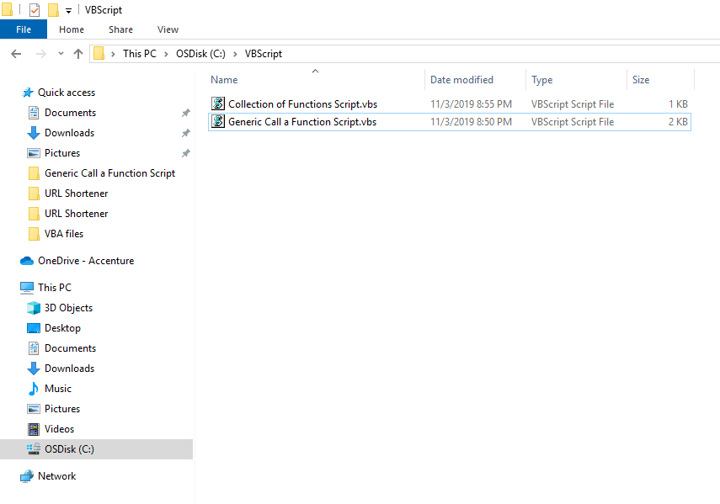

Note: The name in red font color can be changed depending on the user preference

1. Run the VB Script files using your Automation Tool (example: Automation Anywhere)

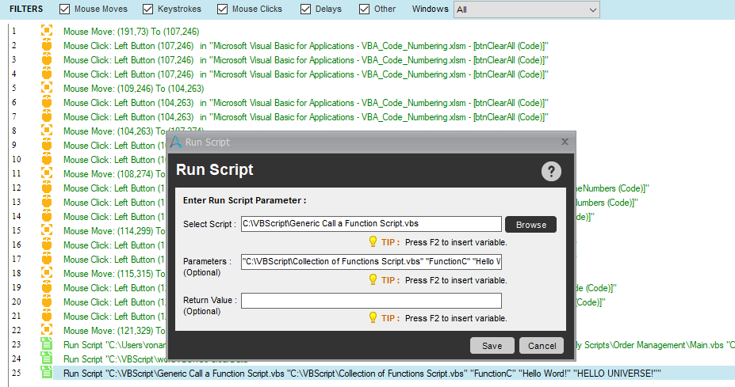

Configure Run Script Command and click Save

***Selection Script:*** Path of Generic Call a Function VB Script file

***Parameters (Optional):*** "Path of Collected Function VB Script File" "Function Name" "Parameter1" "Parameter2"

Example with parameters:

***Selection Script:*** *C:\VBScript\Generic Call a Function Script.vbs*

***Parameters (Optional):*** *"C:\VBScript\Collection of Functions Script.vbs" "FunctionC" "Hello Word!" "HELLO UNIVERSE!"*

Example without parameters:

***Selection Script:*** *C:\VBScript\Generic Call a Function Script.vbs*

***Parameters (Optional):*** *"C:\VBScript\Collection of Functions Script.vbs" "FunctionA"*

Note: The name in red font color can be changed depending on the user preferences.

1. Execute the bot to run the Script.

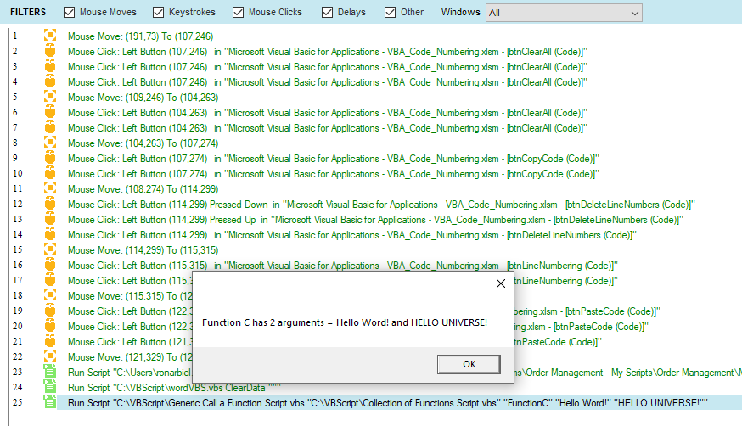

Note: The name in red font color can be changed depending on the user preferences

# Calibration Guide

The user can change the file name of “Generic Call a Function Script.vbs” and Collection of Functions Script.vbs as well as the location of both files needed for automation task. All collected reusable functions can be appended in one single file which is the Collection of Functions Script.vbs in this example.

Actual VB Script code insideaCollection of Functions Script.vbs file

Example of collected functions:

*' ==== COLLECTION OF FUNCTIONS START ====*

*'Function A*

*Function FunctionA()*

*MsgBox "Function A has no argument because there's no parameters"*

*End Function*

*'Function B*

*Function FunctionB(strVar1)*

*MsgBox "Function B has 1 argument = " & strVar1*

*End Function*

*'Function C*

*Function FunctionC(strVar1, strVar2)*

*MsgBox "Function C has 2 arguments = " & strVar1 & " and " & strVar2*

*End Function*

*' ==== COLLECTION OF FUNCTIONS END ====*